Metal Detector Circuit

Design Project Report

Cole Brauer, Michaela Dye, Jacob Knaup, and Shelby Reed

EGR 330pm - Design of Electrical Systems

December 4, 2017

**Table of Contents**

Abstract……………………………………………………………………………………. 4

Introduction………………………………………………………………………………… 4

List of Materials……………………………………………………………………………. 4

Multisim Simulation of Circuit………………………………………………………..…… 5

Circuit and Coils………………………………………………………………………...…. 6

Circuit Construction……………………………………..…………………………. 6

Coil Construction………………………………………………………………...… 7

Coil Calibration………………………………………………………………..…… 7

Results ……………………………………………………….……………….……………. 12

Conclusion and Discussion………………………………………………………..………. 14

References…………………………………………………………………………………. 14

**Table of Figures**

Figure 1: Multisim circuit model………………………………………………………….. 5

Figure 2: Multisim circuit simulating no metal present—inductors balanced…………….. 5

Figure 3: Multisim circuit where search coil has high inductance……………..………….. 6

Figure 4: Multisim circuit with search coil having a lower inductance………………….... 6

Figure 5: The metal detector circuit……………………….…………………………...….. 6

Figure 6: The search coil…………………………..…………………………………...….. 7

Figure 7: Reference coil with adjustable inductance ...….……………………………..….. 7

Figure 8: RL circuit constructed on breadboard for the search coil……………………….. 8

Figure 9: Voltages equalized across the resistor (left) and the search coil (right)…...…….. 8

Figure 10: Frequency for which reactance of search coil and 10 ohm resistor are equal…. 8

Figure 11: Unknown search coil in RL circuit…………………………………………….. 9

Figure 12: Frequency for which voltage amplitudes are equal………………………...….. 9

Figure 13: Variable reference coil in RL circuit……………………………………….….. 10

Figure 14: Reference coil adjusted to be of same L as search coil………………….…….. 10

Figure 15: Second RL circuit constructed on breadboard for reference coil ……………... 11

Figure 16: Voltages equalized across resistor and reference coil………………….………. 11

Figure 17: The frequency of the search coil was used to tune the reference coil to match... 11

Figure 18: Metal detector detecting a steel carpenter’s square………………………...….. 12

Figure 19: Output when no metal is detected (f = 4.68 kHz) …………….……………….. 12

Figure 20: Output when metal is detected (f = 4.98 kHz)…………………………...…….. 13

Figure 21: Metal detector responding to a shallowly buried key…………………....…….. 13

**Abstract**

The main goal of this project was to design, construct, and test a functioning metal detector based upon methods, circuits, and components demonstrated in class. A circuit was designed incorporating a balance network between two inductor coils and a series of amplifier networks that amplify the frequency changes from the two coils that act as inductors to detect metal. The circuit was first modeled in Multisim in order to study and confirm its functionality and then it was physically constructed on a protoboard. Two inductor coils were calibrated by matching their inductance constants using an AC RL circuit. Finally, the completed circuit and coils were tested on a variety of metal objects at shallow depths in order to verify the metal detector’s functionality.

**Introduction**

The primary design of the beat frequency oscillator (BFO) metal detector circuit was found online from a DIY metal detector website [1]. The circuit utilizes two inductors and a collection of transistors to create an amplifier network. This network is highly sensitive to changes in inductances which can be heard through the noise changes from the speaker. The inductors are designed to be of the same characteristics under normal conditions, but given a disturbance that affects one of the inductors, the network will become unbalanced and its output signal will change. The circuit also contains several stages of amplification to boost the signal changes so they can be audible through the speaker.

**List of Materials**

* 1 - 9V rechargeable battery
* 2 - 220 μF 16V electrolytic capacitors
* 5 - 0.01 μF polyester capacitors
* 5 - 0.1 μF polyester capacitors
* 6 - 10 kΩ resistors
* 1 - 1 kΩ resistor
* 1 - 2.2 MΩ resistor
* 2 - 39 kΩ resistors
* 6 - 2N2222A transistors
* 1 - speaker
* 1 - ProtoBoard (8.25 cm x 6.5 cm)
* .25 mm enameled copper wire
* 1 - 15 cm diameter circle from 3 mm plywood
* 2 - 16 cm diameter circles from 3 mm plywood
* 1 - 117 cm long rod for handle
* 1 - 12 mm diameter and 50 mm long dowel rod
* 1 - 5 cm plastic threaded PVC pipe
* 1 - brass nut to fit plastic tube

**Multisim Simulation of Circuit**

In order to demonstrate the circuit before physically building it, it was modeled in Multisim. Within the model, the search coil is represented by inductor 1 (L1) and the reference coil is represented by inductor 2 (L2). In the physical metal detector, placing the search coil near metal will cause the inductance of the coil to change. To simulate the detection of metal, the inductor values were manually altered in the multisim model. When the inductor values are the same, the circuit emits a steady, regular signal. If metal is detected—that is, when the inductors become unbalanced—the output has peaks that are less regular.

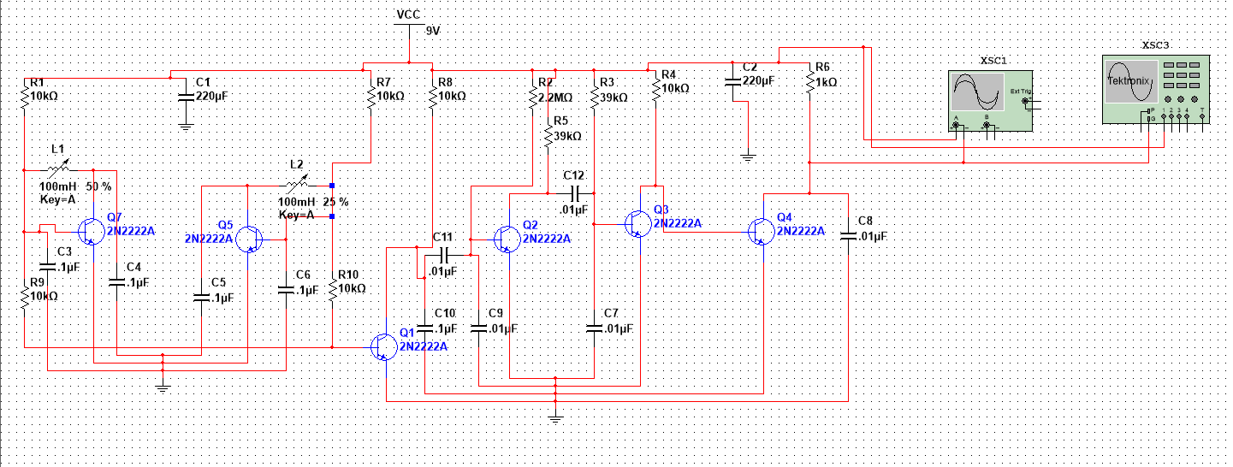

*Figure 1: Multisim circuit model*

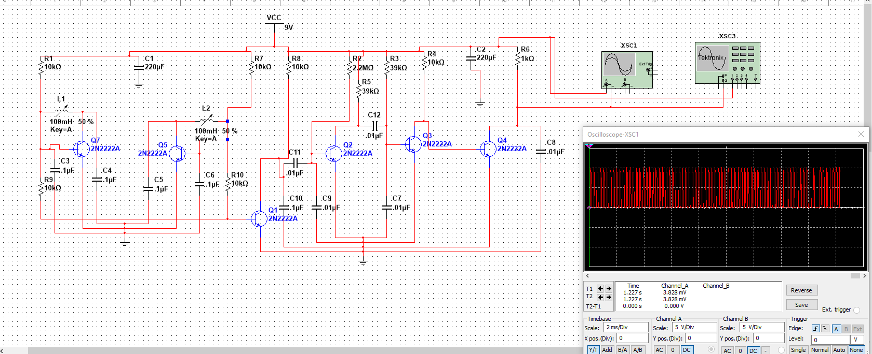

*Figure 2: Multisim circuit simulating no metal present—inductors balanced*

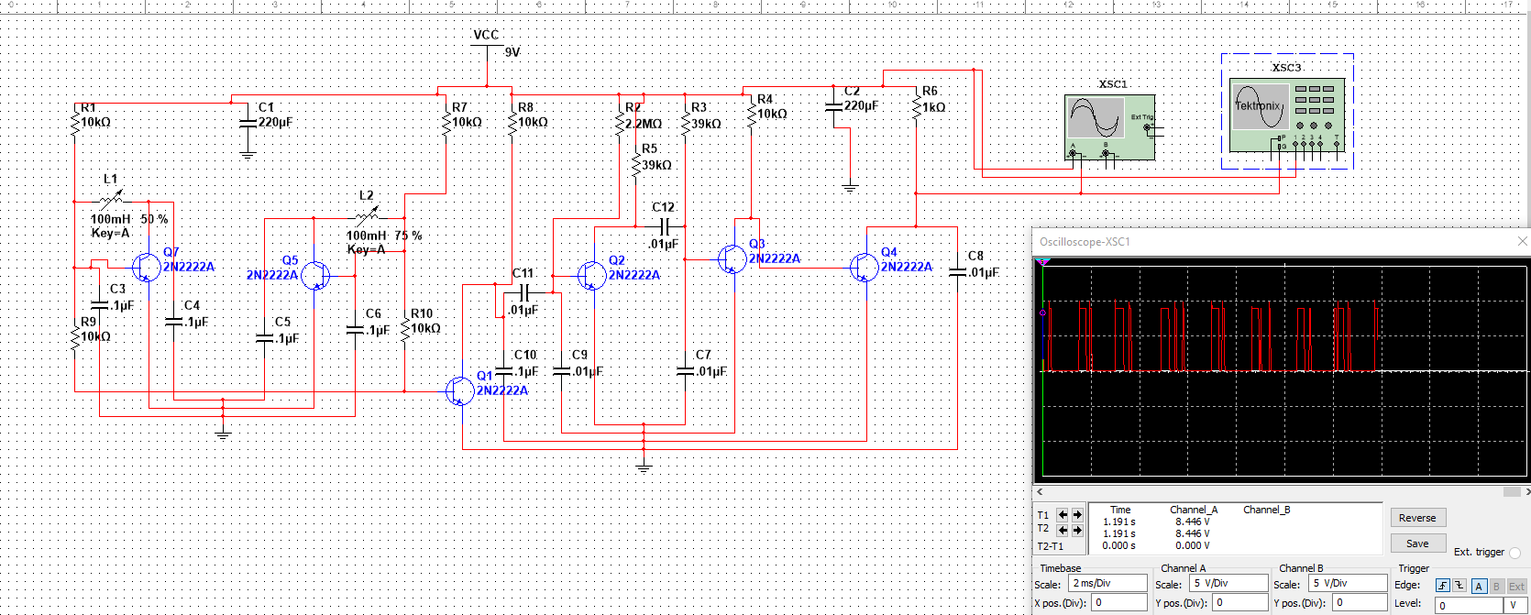

*Figure 3: Multisim circuit where search coil has high inductance*

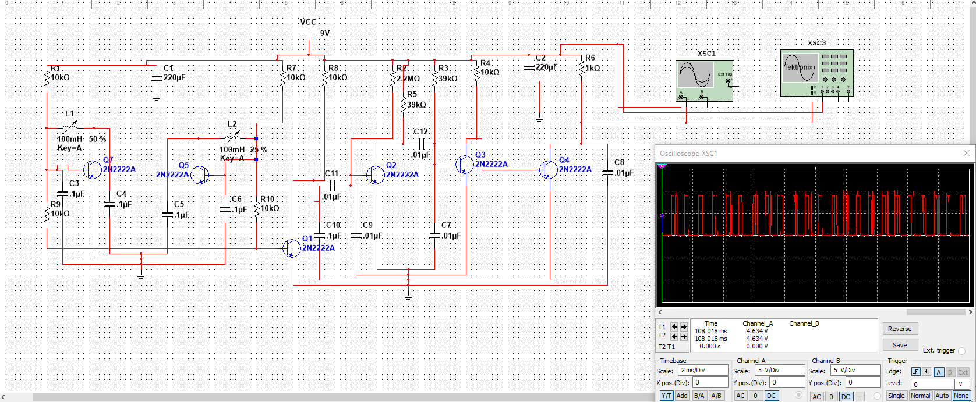

*Figure 4: Multisim circuit with search coil having a lower inductance*

**Circuit and Coils**

Circuit Construction

The circuit is constructed on a ProtoBoard using through-hole components. The ProtoBoard was selected instead of a breadboard because it would decrease the chance of a component coming disconnected during use. The component layout matches the multisim schematic to simplify testing and troubleshooting.

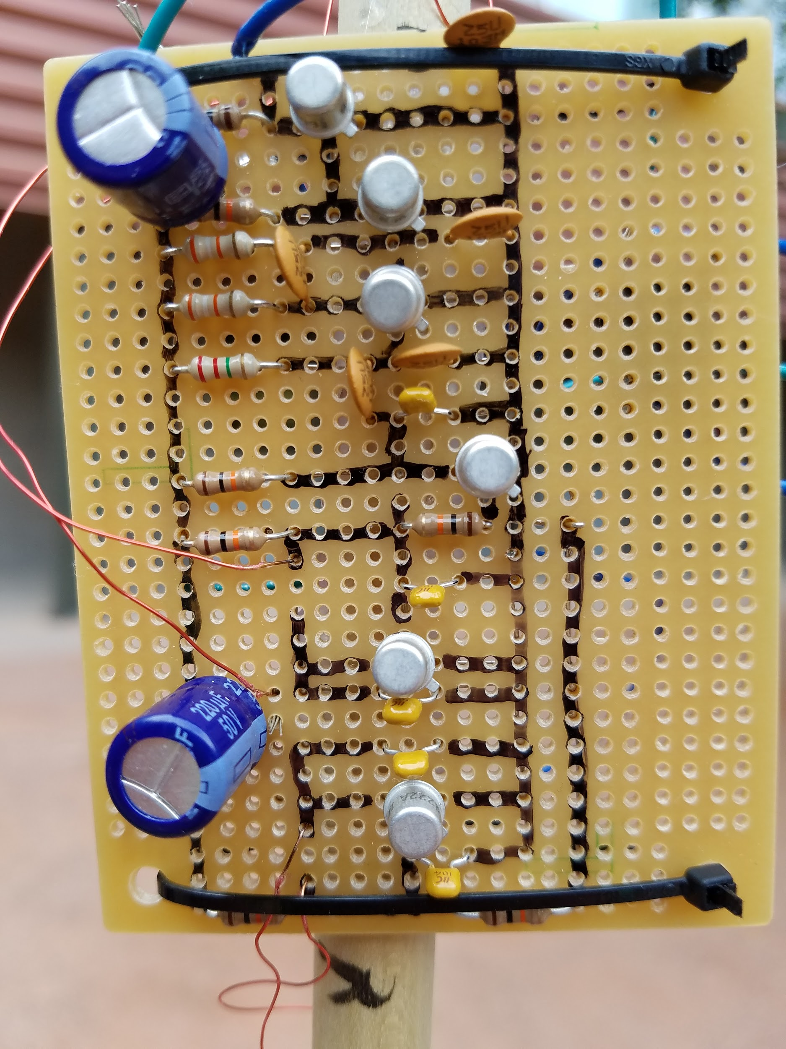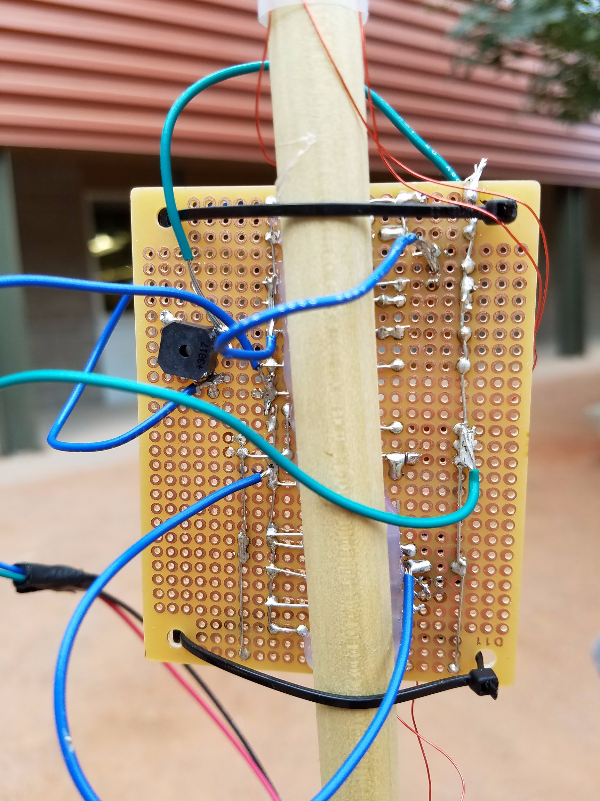

*Figure 5: The metal detector circuit front (left) and back (right)*

Coil Construction

The structure of the search loop is made from a 15 cm diameter disk that is glued between two 16 cm diameter disks. This creates a spool like structure that holds the coil in place. The coil is made out of the enameled wire that is wrapped around the smaller diameter circle 10 times.

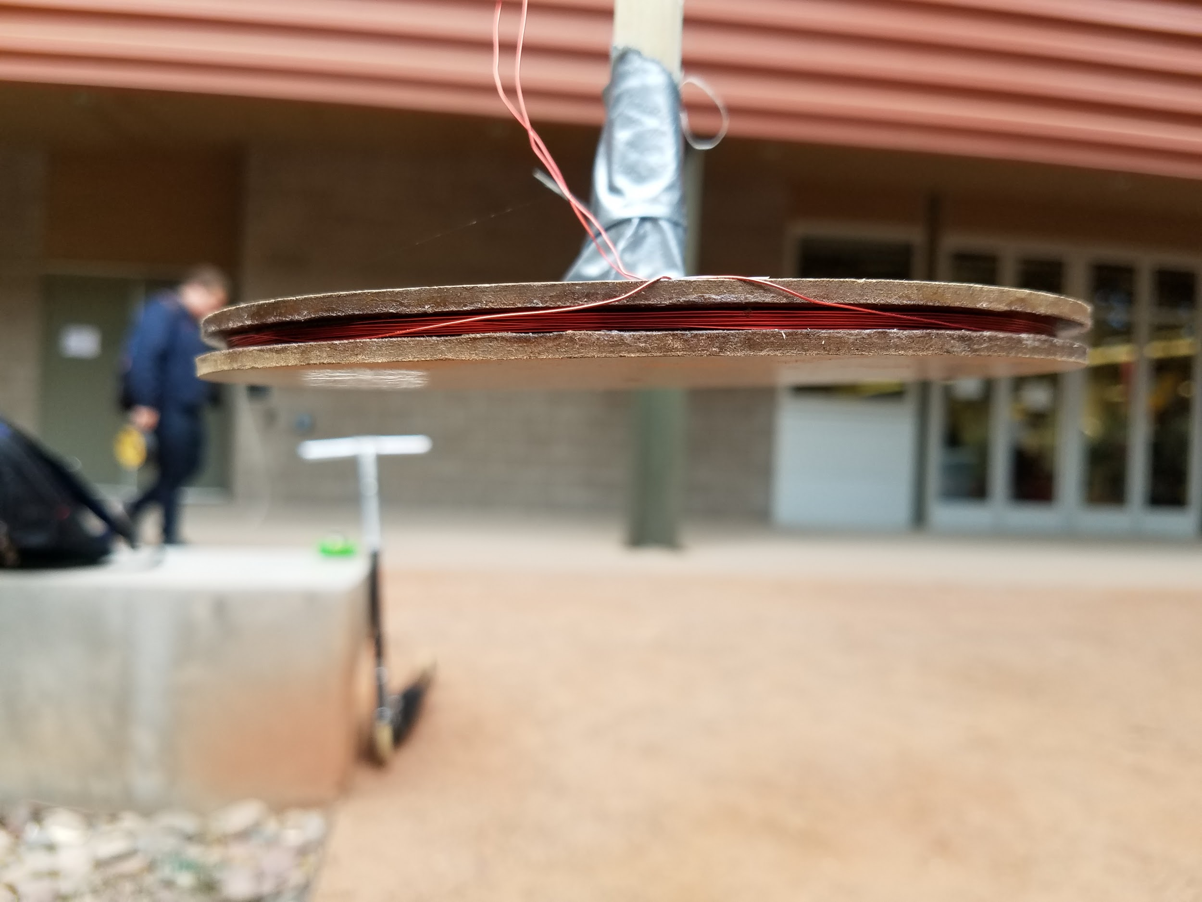

*Figure 6: The search coil*

The reference coil is a much smaller coil and can be constructed from a 12 mm diameter dowel rod, a plastic pipe, brass nut and enameled copper wire. The wire is wrapped around the dowel rod 125 times and then is inserted into the plastic pipe. Then the brass nut can be threaded on the end of the plastic pipe and can be moved to adjust the frequency of the coil to match the frequency of the search coil so the circuit will be balanced.

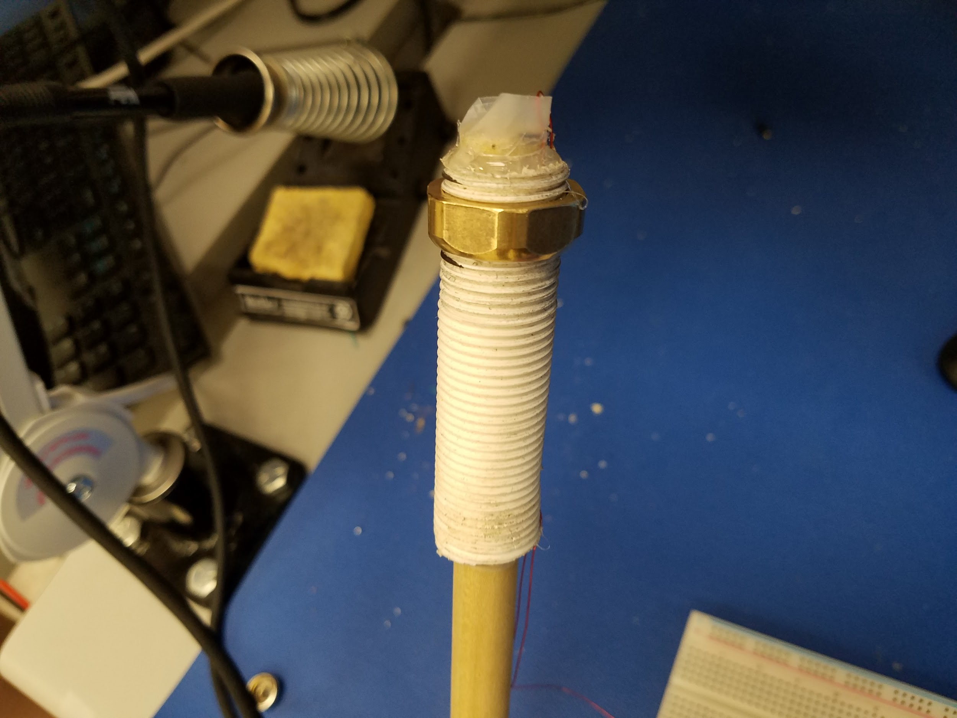

*Figure 7: Reference coil with adjustable inductance*

Coil Calibration

The circuit expects the two coils to be balanced when no metal is present, so it is necessary to ensure that the two coils are constructed in such a way that they have the same inductance (L) value. The reference coil is built in such a way that it has a mechanically adjustable inductance. However, in order to determine where to place the adjustment and to verify that the two coils can be balanced, the following calibration procedure was performed.

An LR circuit was constructed with the search coil and a small known resistor as shown below. An AC signal was run into the circuit and the AC voltage across the resistor and inductor were measured. The frequency was then adjusted until the amplitude of the voltage across the two components was the same. This allowed the inductance L value for the search coil to be determined.

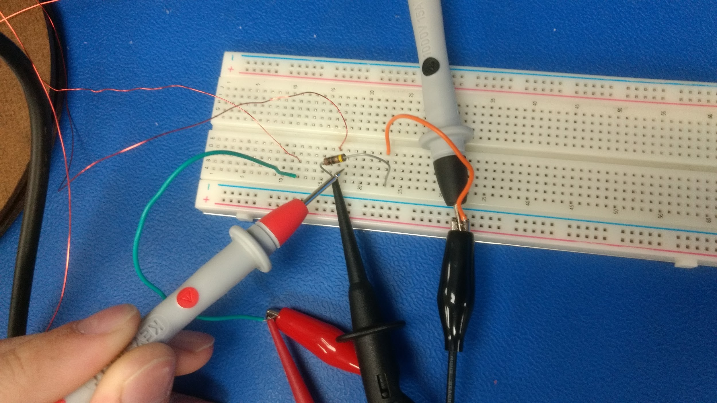

*Figure 8: RL circuit constructed on breadboard for the search coil*

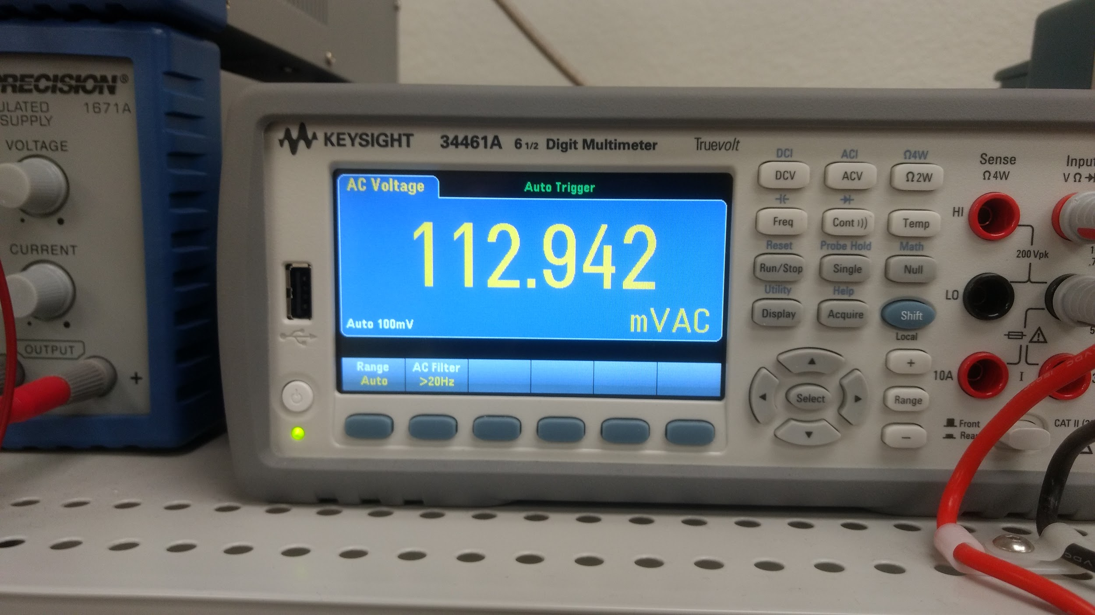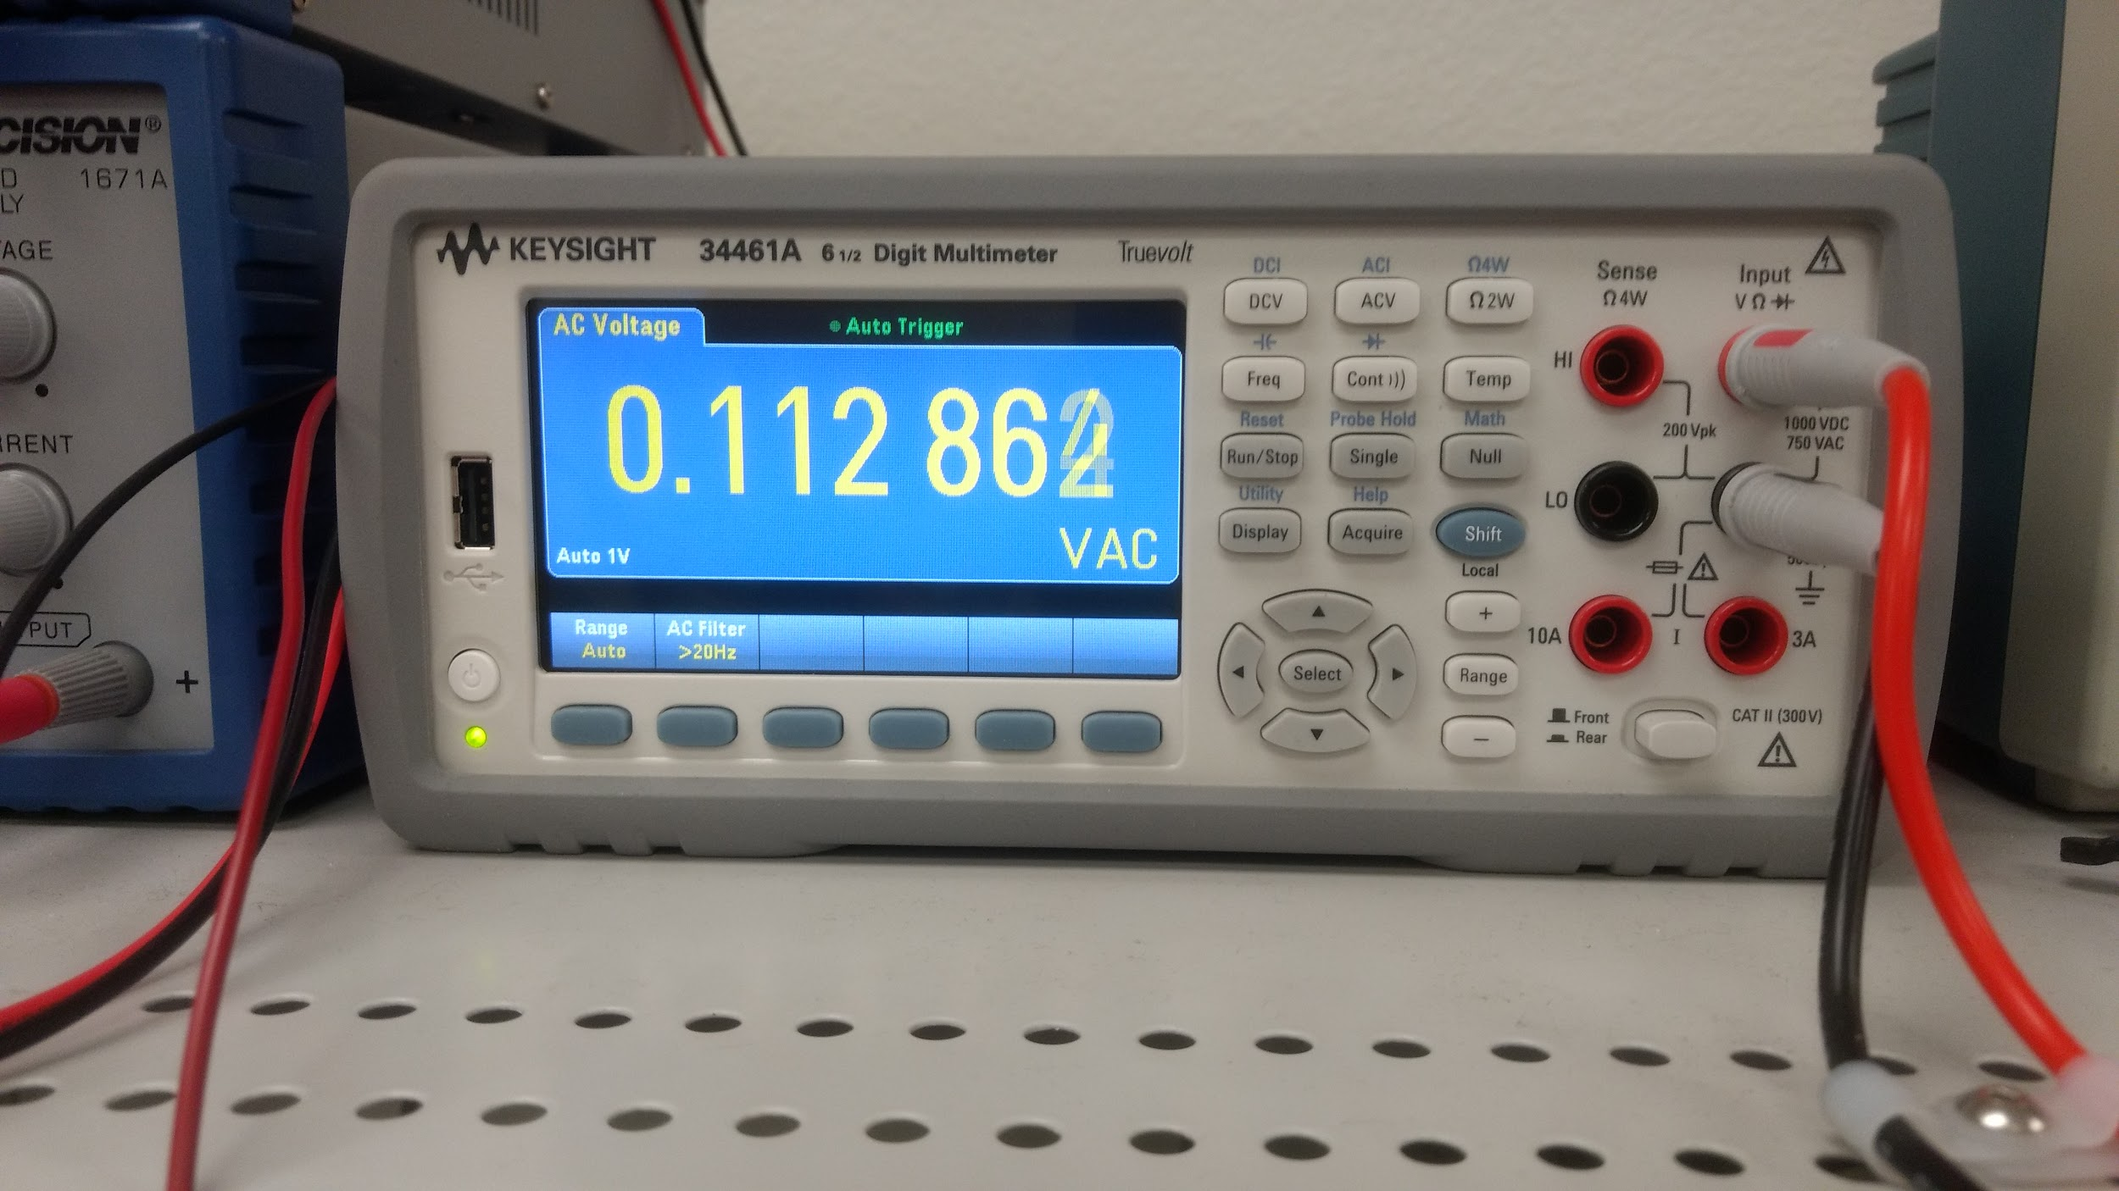

*Figure 9: Voltages equalized across the resistor (left) and the search coil (right)*

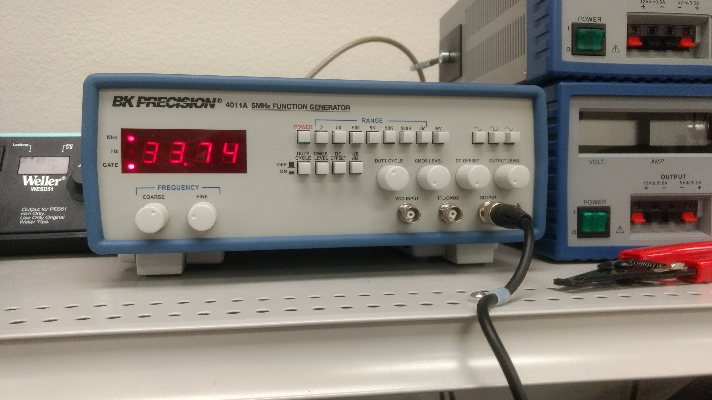

*Figure 10: Frequency for which reactance of search coil and 10 ohm resistor are equal*

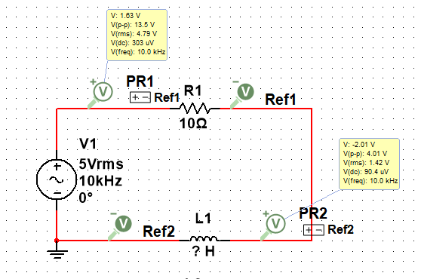

*Figure 11: Unknown search coil in RL circuit*

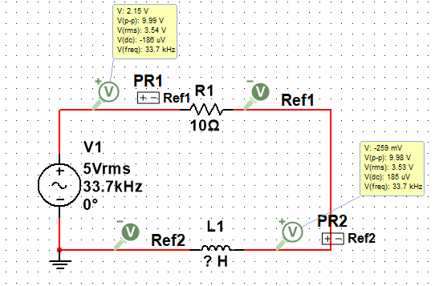

*Figure 12: Frequency for which voltage amplitudes are equal*

The resistance was known to be 10 ohms and the frequency that balanced the voltages was found to be 33.74 kHz.



The components are in series, so they have the same current. And the amplitude of the voltage across each component is equal to the current times resistance or reactance. Therefore, the inductor’s reactance for this frequency is equal to the resistance of the resistor.

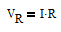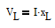

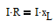

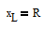

The reactance of an inductor is given by the following.

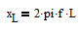

This allows L to be solved as shown below.

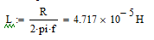

Finally, the same procedure was followed again, this time substituting the reference coil for the search coil. The same resistor was used and the frequency was set to the frequency found to produce the same voltage across the resistor and search coil. The inductance of the reference coil was varied until the voltages were again equal. Therefore, according to the same formulation shown above, the reference and search coils have been calibrated to have the same inductance of L=47.2 uH.

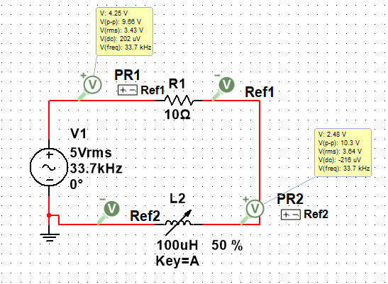

*Figure 13: Variable reference coil in RL circuit*

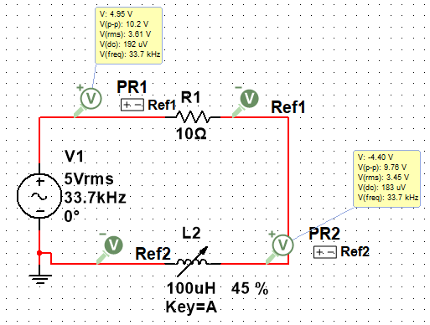

*Figure 14: Reference coil adjusted to be of same L as search coil*

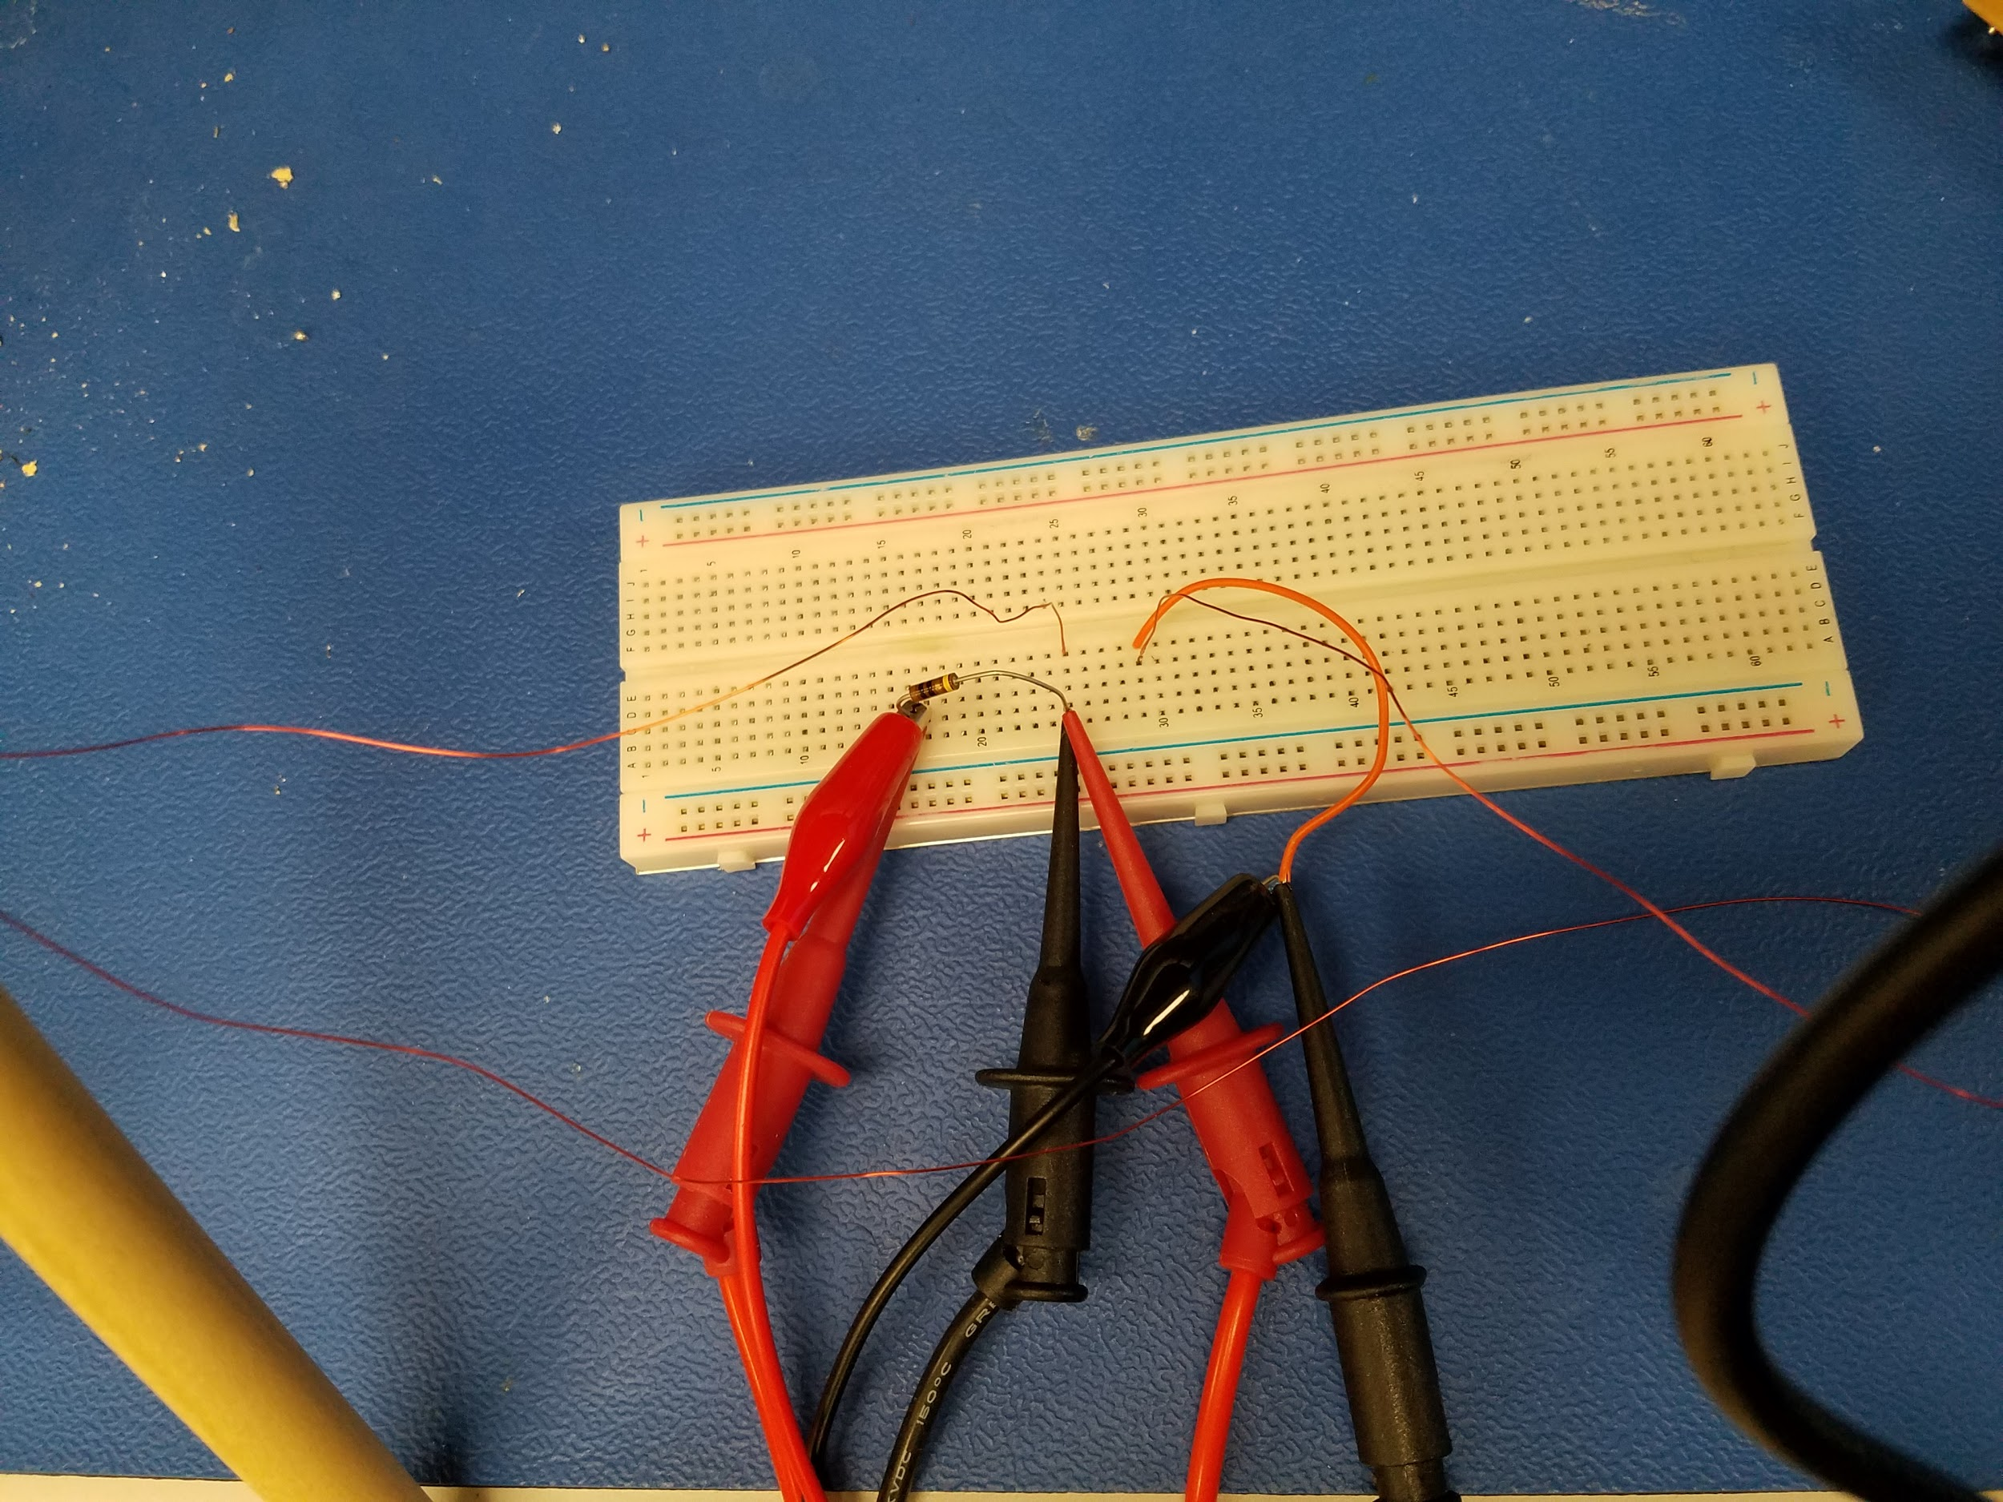

*Figure 15: Second RL circuit constructed on breadboard for reference coil*

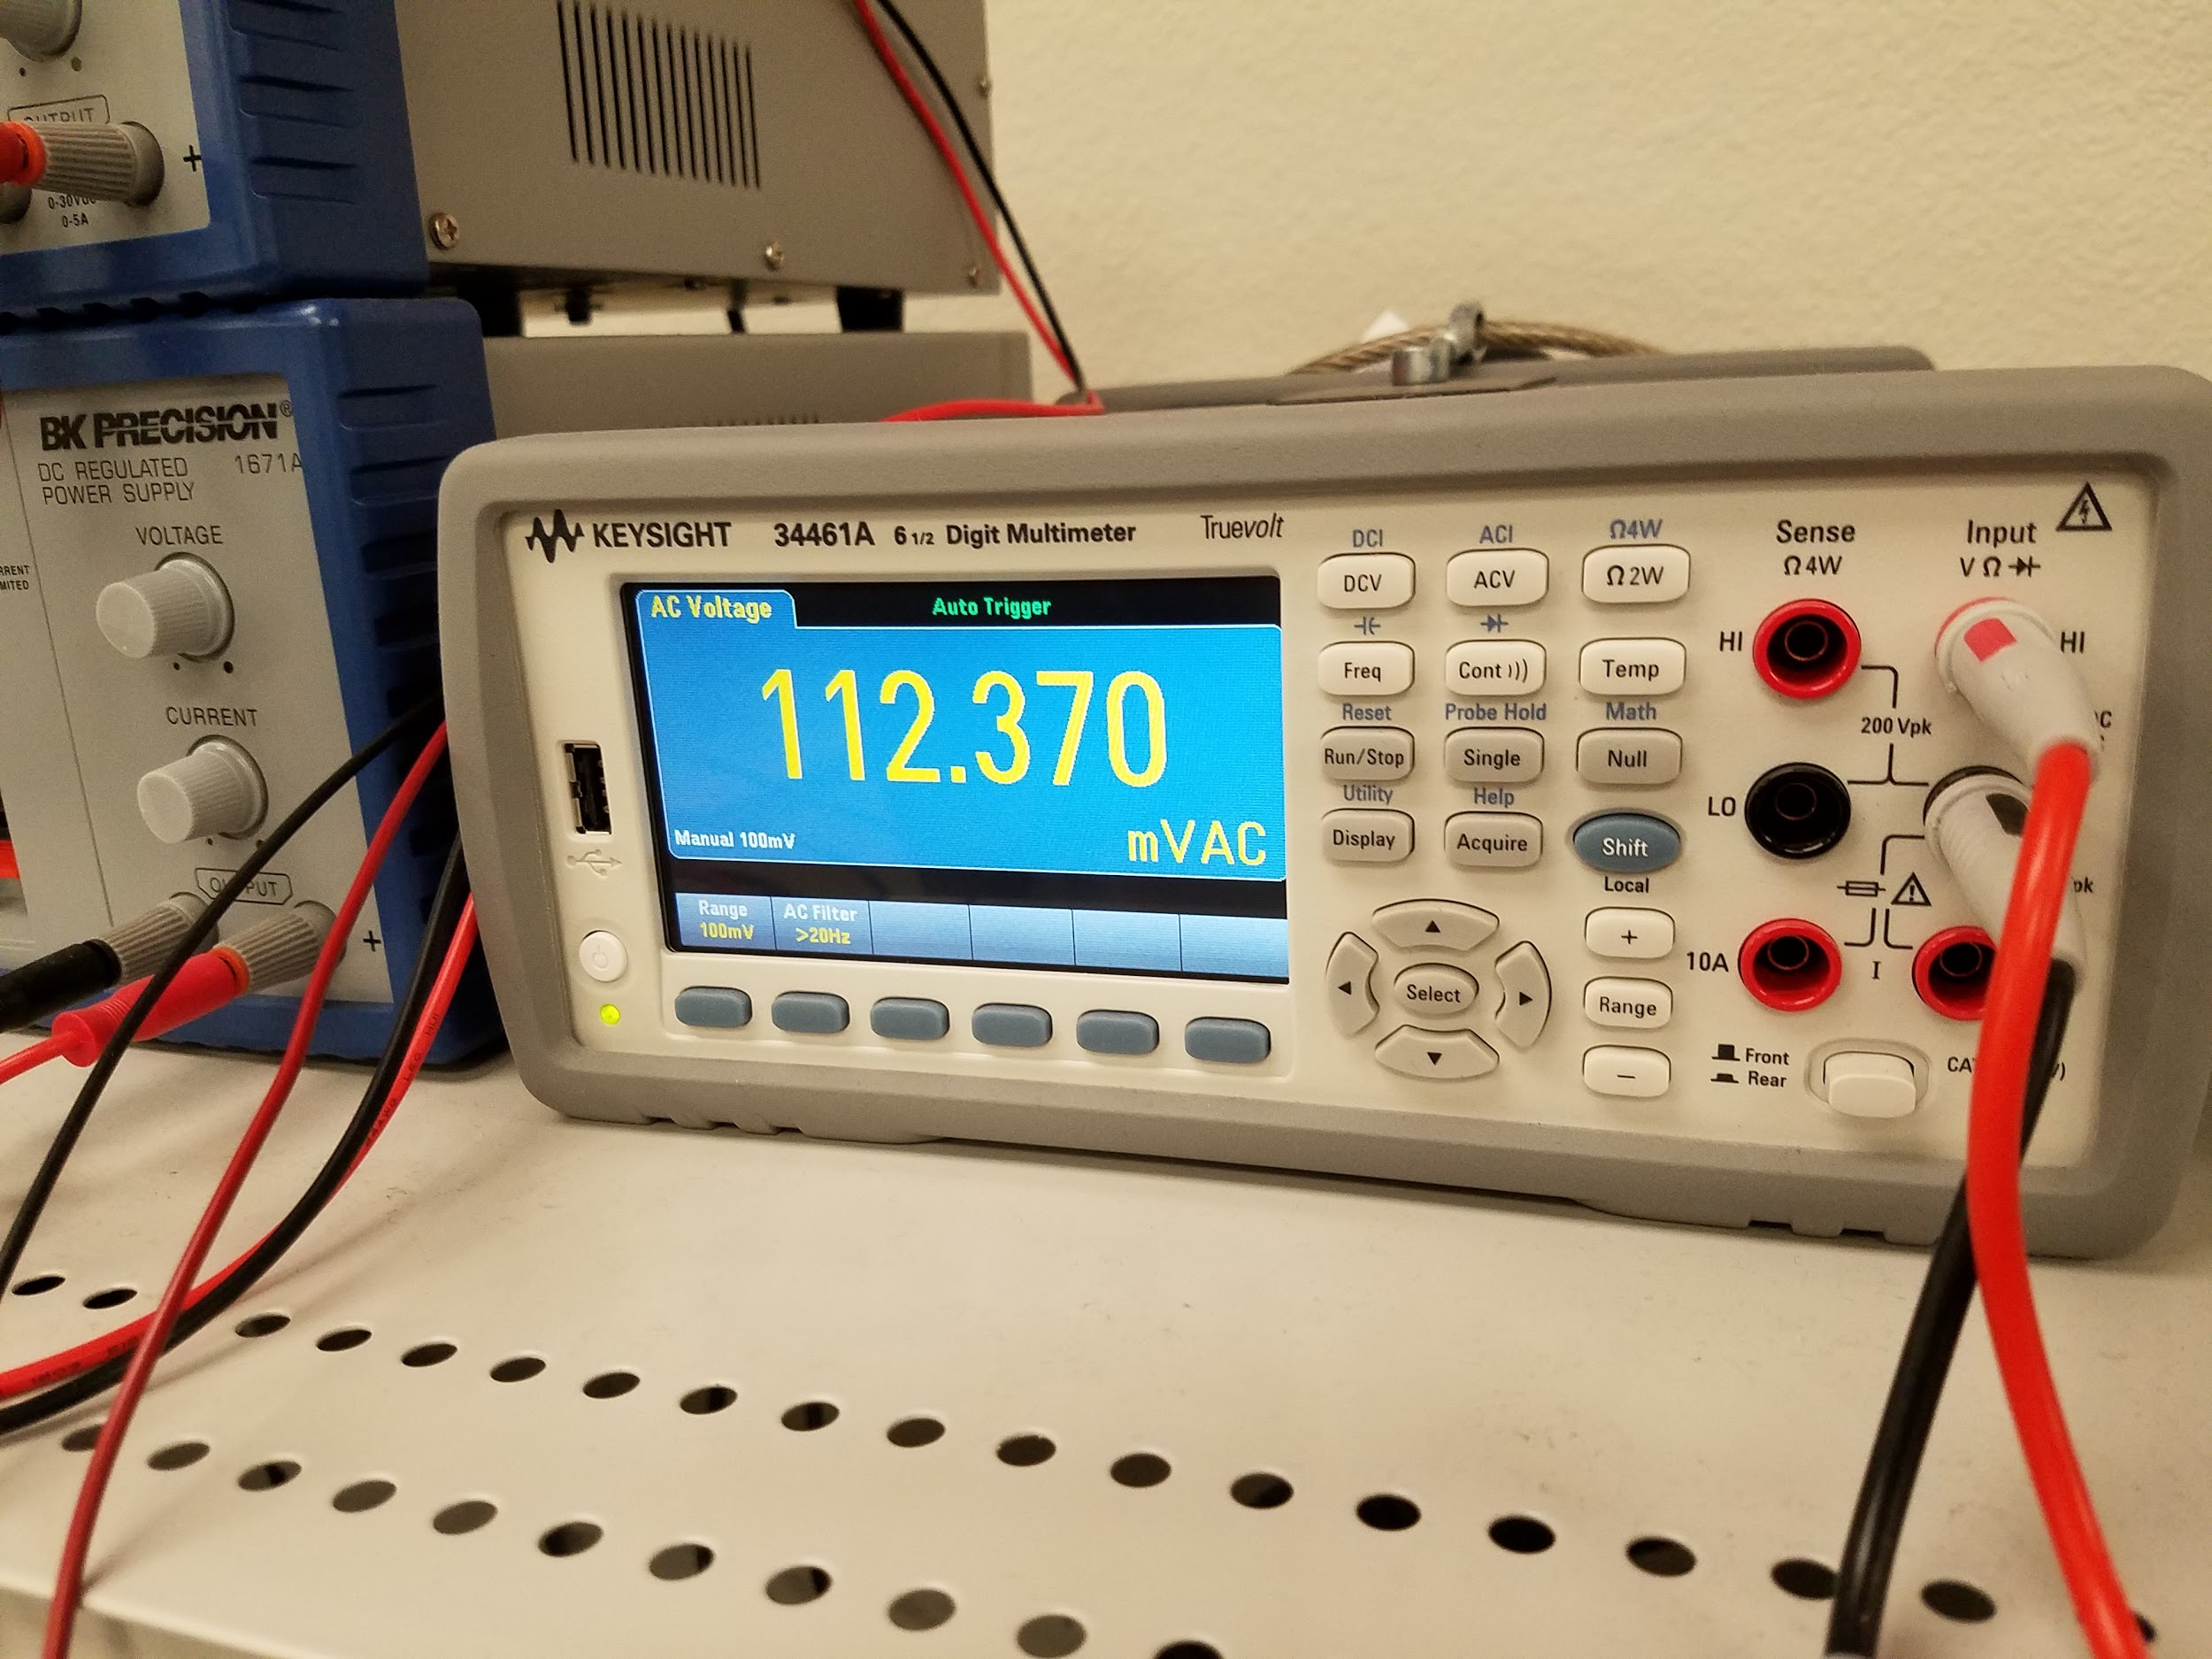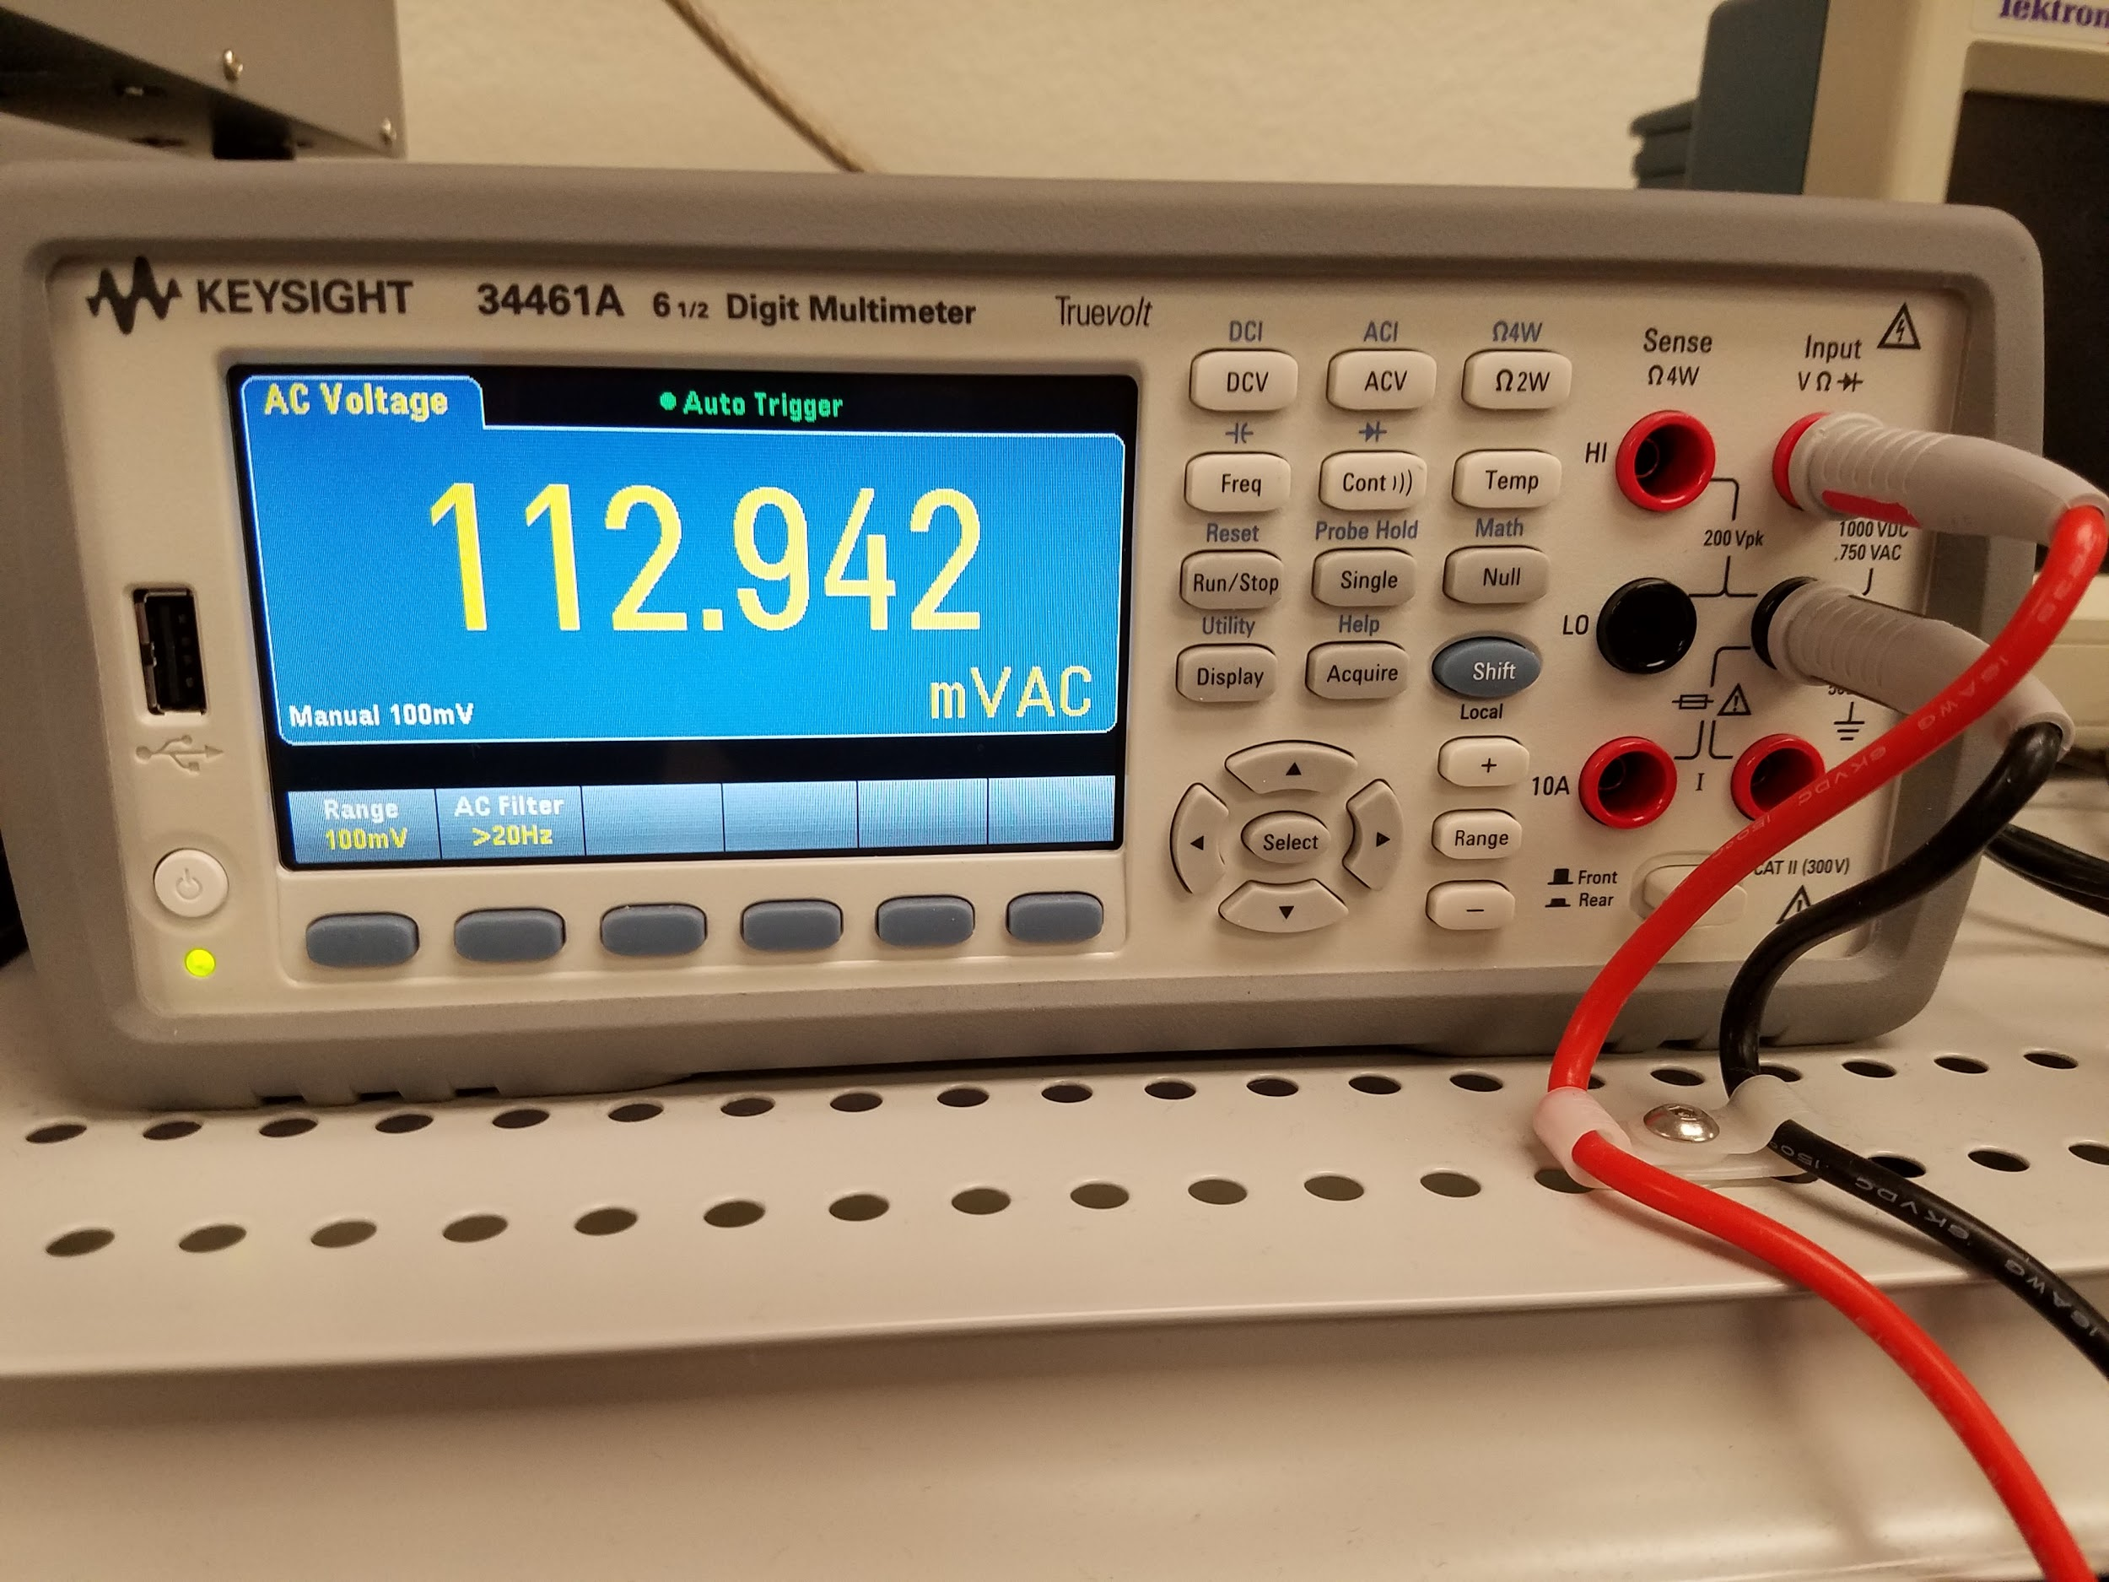

*Figure 16: Voltages equalized across resistor and reference coil*

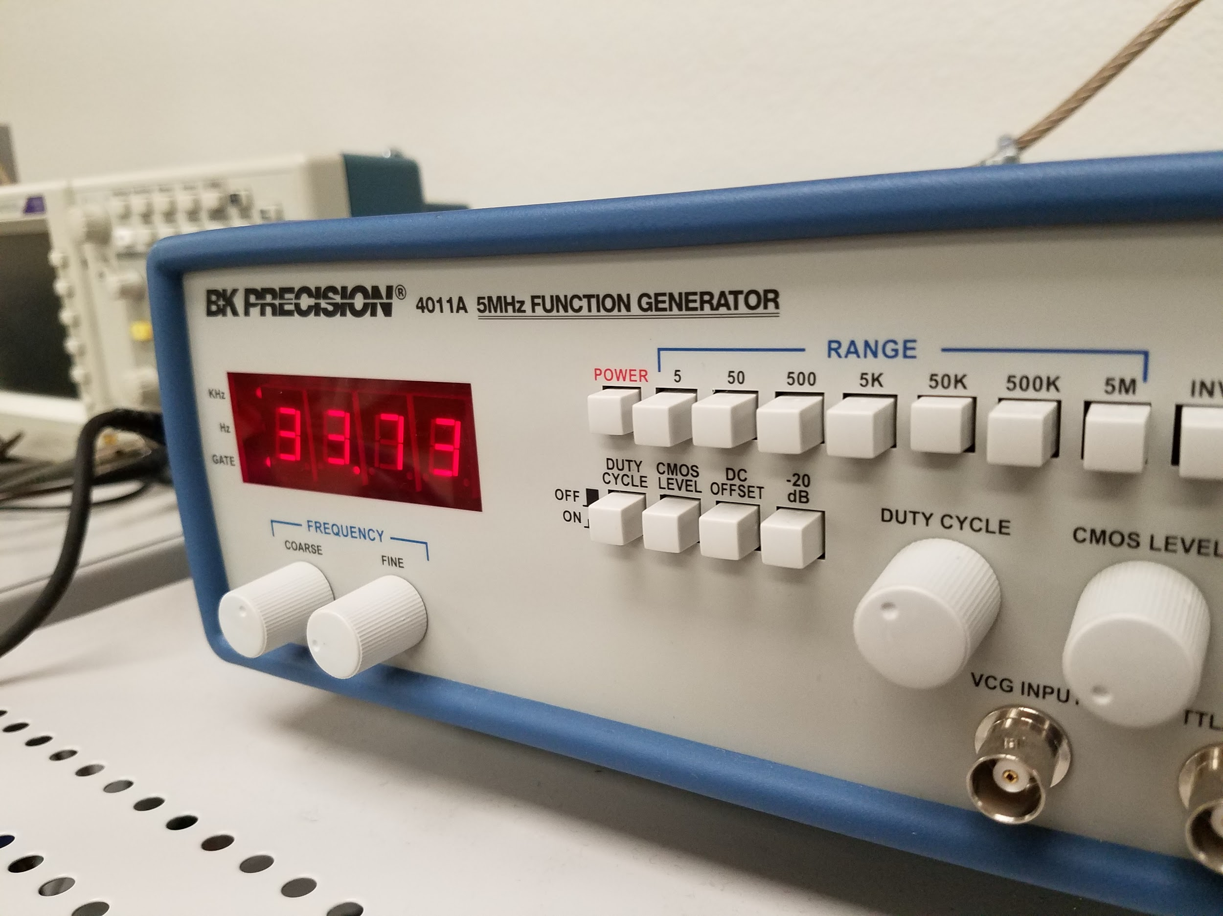

*Figure 17: The frequency of the search coil was used to tune the reference coil to match*

**Results**

The metal detector circuit does detect metal but the depth at which it can detect objects is very small and the objects must be relatively large. Depending on the size of the object, the metal detector can sense it when it is within 0 and 4 inches of it. However, if the object is small, like the size of a ring, the metal detector will not pick it up.

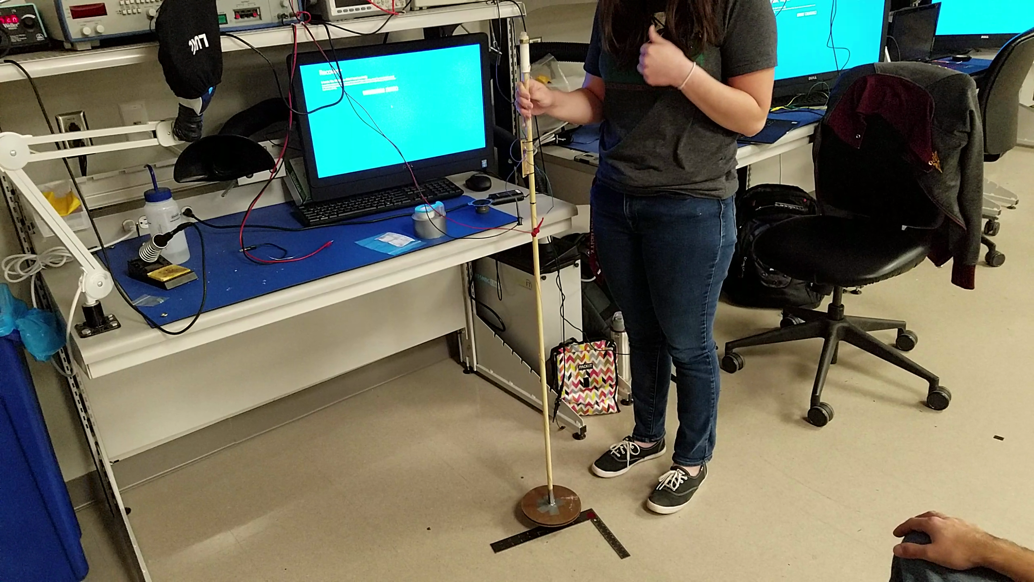

*Figure 18: Metal detector detecting a steel carpenter’s square*

Initially, the metal detected was tested using a bench power supply and with the output connected to an oscilloscope to measure the frequency of the waveform. This setup allowed the predicted functionality to be verified and compared with the multisim model. As shown below, when no metal is near the search coil, the circuit outputs a steady waveform. When metal is brought near the search coil, the frequency of the output increases. In the test shown below, the frequency increased by 300 Hz, from 4.68 kHz to 4.98 kHz

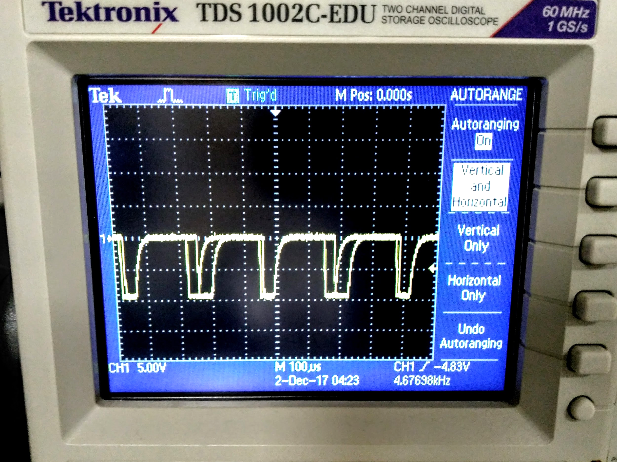

*Figure 19: Output when no metal is detected (f = 4.68 kHz)*

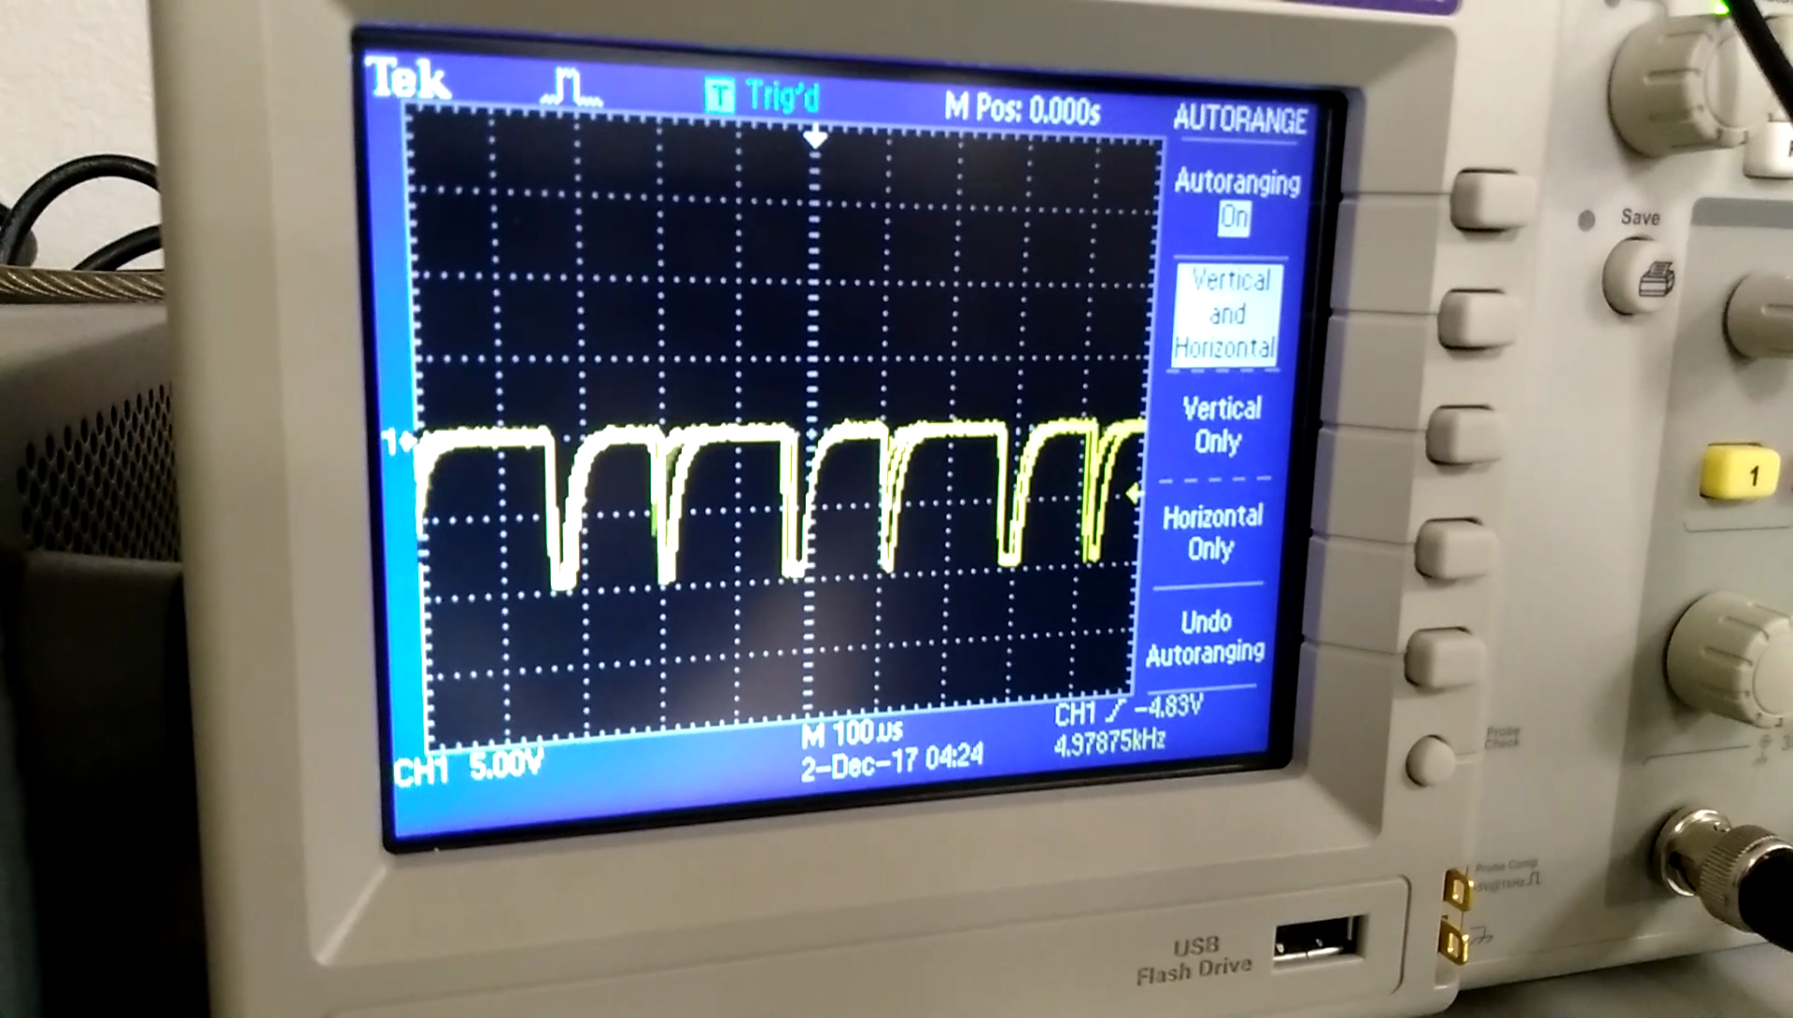

*Figure 20: Output when metal is detected (f=4.98 kHz)*

The completed metal detector is powered by a 9V battery and its output is run through a small buzzer to give an auditory signal to the user. The frequency of the audio signal clearly increases, meaning the audio tone becomes higher pitched, when the end of the metal detector is close to a large ferrous object. The metal detector was first tested with large and highly ferrous objects such as carpenter’s squares and they were easily and clearly detected. Other objects such as a small and non ferrous ring were not detectable. It was also tested on slightly buried objects in addition to unburied objects. These tests showed that a depth greater than a few inches made most objects undetectable. In the image shown below, the metal detector’s response to a key buried at a depth of an inch is barely detectable. As expected, larger objects are able to be detected more clearly at greater depths.

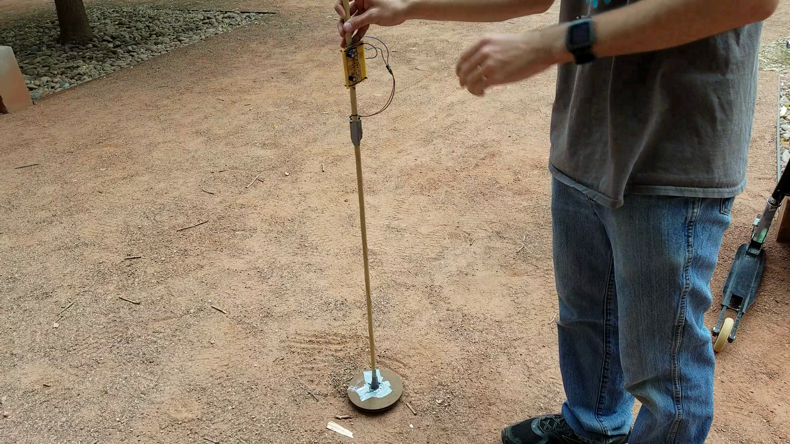

*Figure 21: Metal detector responding to a shallowly buried key*

**Conclusion and Discussion**

Overall, the metal detector does detect metals but it is not very efficient especially when the item is buried under dirt. The range is too small and its sensitivity is too low. In order to increase the range, the size of the search coil could be increased. However, that would decrease its sensitivity to smaller objects. To increase the sensitivity, the search coil size could be decreased but then that decreases its range. In order for this design to be improved in both ways, a more complex circuit and more precise equipment would be needed. One way that this could be accomplished would be to precisely measure the frequency using a microcontroller, interpret that value in software, and then output a signal to the user that is more precise than the tone created directly by the measurement circuit.

Although the metal detector has difficulty responding to small or buried objects, its response to easily-detectable objects was very clean and desirable. The multisim simulation of the detection network showed the output waveform becoming more irregular when the coils were unbalanced. The experimental oscilloscope data, showed the frequency of the waveform very clearly increasing as metal was brought closer to the device. Moreover, using the speaker, this change was easily perceptible to the human ear. The process for calibrating the coils was also very effective as the coils did not require any additional adjustments after the metal detector was fully completed.

**References**

Essex Metal Detectors. “Simple BFO Metal Detector .” *How to Make a Metal Detector*, Essex

Metal Detectors, www.easytreasure.co.uk/bfo2.htm.